# The Teachability of the Materials Developed for Iranian EFL Junior Secondary Program: Prospect I

*Gholam-Reza Abbasian( PhD)[1],*

*Hani Hosseinifar(M.A)[2]*

# Abstract

Materials development and evaluation especially in the field of foreign or second language education have recently received momentum to the extent that the stake holders try to warrant compatibility between teaching -learning theories and those of syllabus design. Principles of teachability and learnability hypotheses seem sound enough to be incorporated in the development and evaluation of materials as a new trend in this field. To this end, this study was an attempt to approach the evaluation of the newly developed materials in the form of a series of textbook (i.e. called Prospect) for Iranian EFL Junior Secondary Program from the teachability perspectives. To do so, this descriptiveexploratory research employed 30 Iranian EFL teachers encouraged to attempt a questionnaire addressing the teachability tenets on one of the textbooks (i.e., Prospect I). Aimed to probing the components of the materials developed in terms of target tenets from the participants’ perspectives, the data analyses revealed that the teachers positively evaluated the textbook in terms of its objectives, design and package, methodology, content selection and grading, language component presentation, discourse and style appropriateness, and listening skills presentation, although they held opposite perspectives on the components of language development. The core message of this study for the stakeholders could be the necessity of serious and rigorous revisions, modifications or adaptations so that the expectations of all consumers can be met.

Key words:Teachability, Materials Evaluation, Materials Development, Iranian Junior Secondary Program, Prospect I

# Introduction

The Teachability Hypothesis is a notion which shows that instruction helps learners to learn a second language in a faster way. In other words, it can speed up the rate of learners‟ L2 development if the learners are taught or instructed on a level that is one stage above their present level (Pienemann, 1985). Pienemann observed that instruction is most effective when it reflects the stage just beyond the learners‟ current stage of interlanguage.

According to Teachability Hypothesis and in accordance with Krashen‟s i+1, it is believed that classroom instruction that is a little above the students‟ level would be obviously more effective for students in learning an L2.

Krashen (1985) recommends that teachers are not supposed to attempt to time instruction to match learners‟ development, but emphasizes the value of language teaching methods based on the provision of “Comprehensible Input.” In his Input Hypothesis, Krashen defines comprehensible input as L2 input just beyond the learner‟s current L2 competence (i+1), in terms of its syntactic complexity. If the input is understood and there is enough of it, the learner will automatically acquire the necessary grammar. He does not believe that focusing on any particular form will alter language acquisition (Lightbown, 2000). At this point, Lightbown (2000) also states that planning lessons around developmental sequences is “neither feasible nor desirable”. Lightbown‟s statement seems reasonable because she states that knowing a language rule does not mean one will be able to use it in communicative interaction. From her statement, it can be inferred that, although there is natural order in learners‟ acquisition, it may not be feasible and desirable if learners cannot communicatively use the rule that is taught.

In addition to the characteristics like: i+1, comprehensibility, adequacy and communicative nature cited for educational materials, their manipulative development and design for teaching purposes are of importance. In this respect, Tomlinson (2011) holds that the complex nature of modern day materials, and the extent to which their use is now widespread, necessitates a means of closely analyzing materials so that we can see ‘inside’ them and take more control over their design and use. He also remarks that materials are one of our main „tools of the trade‟, so it is important that we understand their nature.

# Literature review

Educational materials and textbooks are of great significance in any educational setting, and both teachers and learners could be benefitted from well-prepared materials and textbooks. Textbooks play an important role in making the leap from intentions and plans to classroom activities, by making content available, organizing it, and setting out learning tasks in a form designed to be appealing to students. Consequently, many attempts have been made to directly or indirectly discover whether an actual agreement can be applied over what makes a good standard EFL/ESL textbook or materials.

While some evaluators consider that the degree of a textbook‟s importance “depends on the teachers' own teaching style, the resources available to them and the accepted standards of teaching in every language school, etc. (Ansary & Babaii, 2002), others believe that “there is a limit to what teaching materials can be expected to do for us. The whole business of the management of language learning is far too complex to be satisfactorily catered for by a prepackaged set of decisions embodied in teaching materials” (Allwright, 1981).According to Richards and Renandya (2002), textbooks have a significant role in "social routinization". This is a process in which classroom interaction becomes increasingly stereotyped to reduce the unpredictability and the stress. As a matter of fact, the structure that the teaching/learning system requires could be provided by textbooks.

Besides, many argue that materials have a hidden curriculum that includes attitudes toward knowledge, attitudes toward teaching and learning, attitudes toward the role and relationship of the teacher and student, and values and attitudes related to gender, society, etc. Also Clarke (1989) highlighted the importance of communicative features in textbooks which include authenticity, realism, context, and a focus on the learner.

Regarding the real role of textbooks, there are diverse ideas and perspectives. Allwright (1981) divided the position of textbooks into two major parts; the first is the "deficiency view". In this view, the role of the textbook is to compensate for the deficiencies of the teachers and to see if the syllabus is covered. The second view is "difference view" which sees the role of textbook as carriers of decisions made by someone other than teacher. Some researchers like Hutchinson and Torres (1994) see the textbook as the "possible agent for change".

# Materials

Contrary to Tomlinson (2011), position on the necessity of close analysis of materials to see their “inside” one of the disadvantages of the professional production of contemporary materials is that, for many teachers and learners, they seem to be a thing that has been done or decided, leaving those affected with no option but to accept it and over which they can have little control- the separation of conception from execution (Tomlinson, 2011).

Contrary to this status quo, Tomlinson (2011, p. 25)list a number of features supporting the relationship between SLA and the materials including: effectiveness, facilitative, confidence-building, relevance, usefulness, compatibility with the learners‟ level, authenticity, attention drawing to form, communicative, learner style-oriented, motivating, facilitative for silent period, and whole-person involving.

# Materials Development and Preparation

According to Brian Tomlinson (2011) „materials for language learning‟ will be taken to be anything that can be used to facilitate the learning of a language, including coursebooks, videos, graded readers, flash cards, games, websites and mobile phone interactions, though, inevitably, much of the literature focuses on printed materials. Materials can be informative, instructional, experiential, eliciting and exploratory. Richards‟ (2003, p. 18) comment that “instructional materials generally serve as the basis of much of the language input that learners receive and the language practice that occurs in the classroom”. Tomlinson (2003) and Mashuara (2008) emphasize the role of coursebooks in providing explicit teaching and practice.

Given how important language-learning materials are, it is surprising how little attention they have received until recently in the literature on applied linguistics. It was not until the mid-1990s that materials development began to be treated seriously by academics as a field in its own right.

Materials development has shown its real value since 1990s, as Tomlinson (2003, pp.480-481) states “when materials development became a tool for teachers to help them understand and apply theories of language learning and contribute to their professional development. Either teacherfronted or learner-centered instruction, any classroom needs vehicles and materials to convey the needs, wants, interests and purposes of learners and teachers”.

As cited above, instructional materials may have variety of formats depending on the factors of stake. One of the most common formats is in the form of textbook. However, its preparation, development and analysis require more elaborations so that the learner should figure out that the job and doing educational career cannot be that easy.

# Materials Evaluation

Evaluation is considered as an integral part in the educational process and there is a vast literature on textbook evaluation. Williams (1983), Sheldon (1988), Brown (1995), Cunningsworth (1995), Skierso (2001), and Garinger (2001) are amongst many who have theorized on the nature of the textbook evaluation and developed and introduced various criteria, areas, and categories.

Given their efforts, there are many factors that contribute to the success or failure of students in achieving the instructional goals. Chief among these factors is the instructional materials or textbooks available for students. Generally speaking, “an evaluation is a judgment of merits, sometimes based solely on the measurement such as those provided by test scores but more frequently involving the synthesis of various measurement, critical incidents, subjective impressions, and other kinds of evidences” (Ebel, 1980, p. 554).It is one element of the general model of scientific procedure consisting of the formulation of the intention, program of implementation, implementation and evaluation. “The process of materials evaluation can be seen as a way of developing our understanding of the ways in which it works and, in doing so, of contributing to both acquisition theory and pedagogic practices. It can also be seen as “one way of carrying out action research” (Tomlinson, 2003, p.238).

According to Hutchinson and Waters (1987, p. 34) “textbook evaluation is basically analytical matching process: matching needs to available solutions”. While many believe that textbooks, especially course books represent a problem and lead to instructional failure, others have different perspective regarding the issue. Sheldon (1988, p. 42) stated “whether we like it or not, textbooks represent for both students and teachers the visible heart of any ELT program. The selection of a particular core volume signals an executive educational decision in which there is considerable professional, financial, and even political investment”. To sum it up, this high profile means that the definition and application of systematic criteria for assessing course books are vital.

It is believed that textbooks are of great popularity and they will most likely continue to enjoy this popularity. “Textbooks have become the most important resources for achieving the aims and objectives and meeting the learner needs. Moreover, textbooks should not specify or impose the objectives or become the aims of the instructional programs, but they should be at the service of teachers or learners” (Brown, 2001, p. 12).In fact, “the choice is not whether to use or reject the textbooks, but adaptation as a third alternative can be an efficient alternative” (Allwright, 1981, p. 27). To adopt a textbook, we ought to scrutinize the textbook meticulously and examine the ways in which it is sensitive to learning– teaching process. Textbook evaluators should attempt to establish and apply a wide variety of relevant and contextually appropriate criteria for the evaluation of textbooks that are going to be used.

According to Cunningsworth (1984, p. 22), “there is a need to ensure that the textbook is selected carefully and it reflects the needs of the learners and the aims, methods and values of the teaching program. Attention should be given to principles and procedures for developing criteria for specific situation in which the textbook is used”.

Given the trend discussed, the rationale behind this study originates from lack of systematic evaluation of the newly developed materials for Iranian Junior Secondary Program enjoy in terms of teachability characteristics. Since the English coursebook (i.e. Prospect I) for Iranian Junior Secondary Program has been newly developed, it is in its initial steps for evaluation and assessment. This study seems to be one of the earliest in its kind to evaluate not only the content of the book but the criteria for teachability from the teachers‟ perspectives.

# Research Question

To address the problem raised, the purpose of the study was converted into the following research question:

Do the materials developed for Iranian Junior Secondary Program enjoy teachability characteristics from the teachers‟ perspectives?

**Method**

**Participants**

The participants of this study were 30 English teachers in Junior Secondary Program in Tehran holding at least B.A in one of the English majors i.e. English translation, English literature or English teaching.

**Instrumentation**

The following measurement instruments were used to carry out this research.

1. An open-ended questionnaire was administered among the teachers.
2. Perspective teachability inventory developed out of the open-ended questionnaires was distributed among the teachers.
3. A standardized model of content evaluation was used drawn from the perspectives of teachability.

**Procedures**

1. A group of respective teachers were interviewed in order to develop more comprehensive themes of teachability.
2. The teachers were required to fill out an open-ended questionnaire developed based on the themes extracted from the interview to express the ideas on the teachability of materials.
3. A Checklist of *teachability* factors was developed based on the openended questionnaire to be used as the measure of teachability criteria from teachers‟ perspectives.
4. Teachability checklists was validated by piloting and examining the content with regard to the answers provided by them as well as the interviews. (5) The content analysis was done based on the extracted criteria of teachability by adapting them to the Cunningsworths‟ checklist for course book analysis.

**Results**

The research question of the current study inquired whether “the materials developed for Iranian Junior Secondary Program (i.e., Prospect I) enjoy teachability characteristics from the teachers‟ perspectives”. This research question was addressed taking into account eight categories including objectives, design and package, methodology, selection of content and grading, language component presentation, discourse and style appropriacy, language development, listening skills presentation for each of which Chisquare and frequency analyses were run.

Table 1 shows majority of the teachers almost equally believed that the Prospect I enjoyed adequate (30 %, Residual = 209) and good (29.5 %, Residual = 200) teachability characteristics, although 21.6 percent (Residual = 34) of the respondents‟ perception was poor. The two extreme options, i.e. excellent (10 %, Residual = -211) and totally lacking (9 %, Residual = 232) were selected less than what was expected. Figure 1 also illustrate the teachers‟ evaluation in percent.

Table 1

*Frequencies and Percentages; Teachability Characteristics*

Frequency Percent Residual

|  |  |  |  |
| --- | --- | --- | --- |
| Totally Lacking  Poor  Teachability Adequate  Characteristics Good | 188  454  629  620 | 9.0  21.6 30.0  29.5 | -232.0  34.0  209.0  200.0 |
| Excellent | 209 | 10.0 | -211.0 |
| Total | 2100 | 100.0 | |

The results of chi-square (χ2 (4) = 436.14, p < .05,) indicated that the differences observed in Table 2 were statistically significant. Thus, it can be concluded that the Iranian EFL teachers evaluated the teachability characteristics of the Prospect I as good and adequate.

*Table 2*

*Chi-Square; Teachability Characteristics*

|  |  |
| --- | --- |
|  | Choices |
| Chi-Square | 436.148a |
| Df | 4 |
| Asymp. Sig. | .000 |

a. 0 cells (0.0%) have expected frequencies less than 5. The minimum expected cell frequency is 420.0.

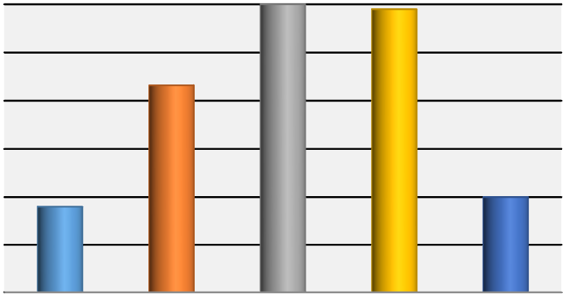

Totally

Lacking

Poor

Adequate

Good

Excellent

Series1

9

21.6

30

29.5

10

Series1, Totally

Lacking, 9

Series1, Poor,

21.6

Series1,

Adequate, 30

Series1, Good,

29.5

Series1,

Excellent, 10

*Figure 1. Percentages Teachability Characteristics*

# Objectives

As Table 3 shows, almost 68 percent of the respondents believed that the Prospect One‟s objectives were adequate (33.3 %, Residual = 16) and good (35.8 %, Residual = 19). Although the residual value was less than expectation (-4), about 17 percent evaluated the textbooks‟ objectives as excellent. The negative options were selected less than what was expected; totally lacking (.8 %, Residual = -23) and poor (13.3 %, Residual = -8).

*Table 3*

*Frequencies and Percentages; Objectives*

Frequency Percent Residual

|  |  |  |  |
| --- | --- | --- | --- |
| Totally Lacking  Poor  Adequate  Objectives  Good | 1  16  40  43 | .8  13.3 33.3  35.8 | -23.0  -8.0  16.0  19.0 |
| Excellent | 20 | 16.7 | -4.0 |
| Total | 120 | 100.0 |  |

The results of chi-square (χ2 (4) = 51.08, p < .05,) indicated that the differences observed in Table 3 were statistically significant. Thus, it can be concluded that the Iranian EFL teachers evaluated the objectives of the Prospect I as good and adequate. Figure 2 also illustrate the teachers‟ evaluation in percent

.

*Table 4*

*Chi-Square; Objectives*

|  |  |
| --- | --- |
|  | Choices |
| Chi-Square | 51.083a |
| Df | 4 |
| Asymp. Sig. | .000 |

a. 0 cells (0.0%) have expected frequencies less than 5. The minimum expected cell frequency is 24.0.

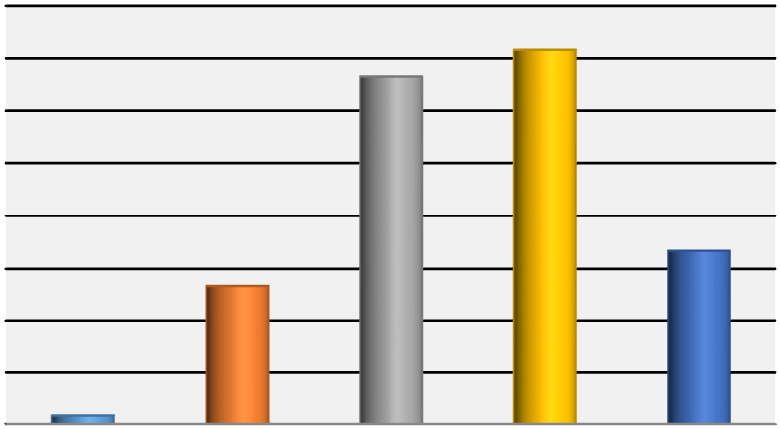

Totally

Lacking

Poor

Adequate

Good

Excellent

Series1

0.8

13.3

33.3

35.8

16.7

Series1, Totally

Lacking, 0.8

Series1, Poor,

13.3

Series1,

Adequate, 33.3

Series1, Good,

35.8

Series1,

Excellent, 16.7

*Figure 2. Percentages Objectives*

Design and Package The teachers believed that the Prospect One‟s design and package had a good (31.1%, Residual = 30) and adequate quality (27.8 %, Residual = 21). Another 11.9 percent evaluated this characteristic as excellent although the residual value was below expectation (Residual = -22). On the other hand 8.5 percent believed that the Prospect I totally lacked appropriate design and package and another 20.7 percent evaluated them as poor.

*Table 5*

*Frequencies and Percentages; Design and Package*

Frequency Percent Residual

|  |  |  |  |
| --- | --- | --- | --- |
| Totally Lacking  Poor  Design  Adequate  and  Good  Package  Excellent | 23  56  75  84  32 | 8.5  20.7 27.8 31.1  11.9 | -31.0  2.0  21.0 30.0  -22.0 |
| Total | 270 | 100.0 |  |

The results of chi-square (χ2 (4) = 51.66, p < .05,) indicated that the differences observed in Table 5 were statistically significant. Thus, it can be concluded that the Iranian EFL teachers evaluated the design and package of the Prospect I as good and adequate. Figure 3 also illustrate the teachers‟ evaluation in percent.

*Table 6*

*Chi-Square; Design and Package*

|  |  |
| --- | --- |
|  | Choices |
| Chi-Square | 51.667b |
| Df | 4 |
| Asymp. Sig. | .000 |

a. 0 cells (0.0%) have expected frequencies less than 5. The minimum expected cell frequency is 54.0.

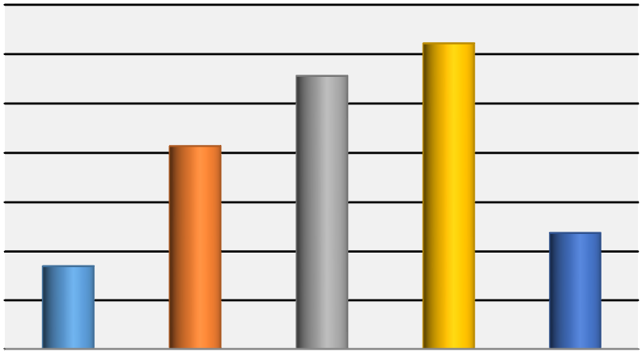

Totally

Lacking

Poor

Adequate

Good

Excellent

Series1

8.5

20.7

27.8

31.1

11.9

Series1, Totally

Lacking, 8.5

Series1, Poor,

20.7

Series1,

Adequate, 27.8

Series1, Good,

31.1

Series1,

Excellent, 11.9

*Figure 3. Percentages Design and Package*

# Methodology

The methodology of Prospect I can be evaluated as adequate (32.2 %, Residual = 22) and good (32.8 %, Residual = 23) while 21 percent (Residual = 3) believed it to be poor. A small percentage of responses, i.e. 8.3 % and 5 %, evaluate the methodology as totally lacking and excellent.

*Table 7*

*Frequencies and Percentages; Methodology*

Frequency Percent Residual

|  |  |  |  |
| --- | --- | --- | --- |
| Totally Lacking  Poor  Adequate Methodology  Good | 15  39  58  59 | 8.3  21.7 32.2  32.8 | -21.0  3.0  22.0  23.0 |
| Excellent | 9 | 5.0 | -27.0 |
| Total | 180 | 100.0 |  |

The results of chi-square (χ2 (4) = 60.88, p < .05,) indicated that the differences observed in Table 7 were statistically significant. Thus, it can be concluded that the Iranian EFL teachers evaluated the methodology of the Prospect I as good and adequate. Figure 4 also illustrate the teachers‟ evaluation in percent.

*Table 8*

*Chi-Square; Methodology*

|  |  |
| --- | --- |
|  | Choices |
| Chi-Square | 60.889c |
| Df | 4 |
| Asymp. Sig. | .000 |

a. 0 cells (0.0%) have expected frequencies less than 5. The minimum expected cell frequency is 36.0.

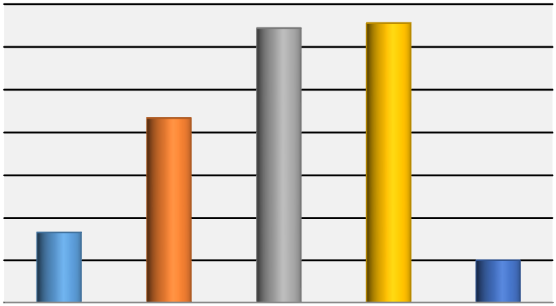

Totally

Lacking

Poor

Adequate

Good

Excellent

Series1

8.3

21.7

32.2

32.8

5

Series1, Totally

Lacking, 8.3

Series1, Poor,

21.7

Series1,

Adequate, 32.2

Series1, Good,

32.8

Series1,

Excellent, 5

*Figure 4. Percentages Methodology*

# Selection of Content and Grading

As Table 9 shows, majority of the teachers believed that the content was well (33.3 %, Residual = 16) and adequately (33.3 %, Residual = 16) selected and graded for Prospect I. The other choices were selected below expectation, i.e. 9.2 % excellent, 16.7 % poor and 7.5 % totally lacking.

*Table 9*

*Frequencies and Percentages; Selection of Content and Grading*

Frequency Percent Residual

|  |  |  |  |
| --- | --- | --- | --- |
| Totally Lacking  Poor  Selection of Content Adequate  and Grading Good | 9  20  40  40 | 7.5  16.7 33.3  33.3 | -15.0  -4.0  16.0  16.0 |
| Excellent | 11 | 9.2 | -13.0 |
| Total | 120 | 100.0 |  |

The results of chi-square (χ2 (4) = 38.41, p < .05,) indicated that the differences observed in Table 9 were statistically significant. Thus, it can be concluded that the Iranian EFL teachers evaluated the selection of the content and grading for the Prospect I as good and adequate. Figure 5 also illustrate the teachers‟ evaluation in percent.

*Table 10*

*Chi-Square; Selection of Content and Grading*

|  |  |
| --- | --- |
|  | Choices |
| Chi-Square | 38.417a |
| Df | 4 |
| Asymp. Sig. | .000 |

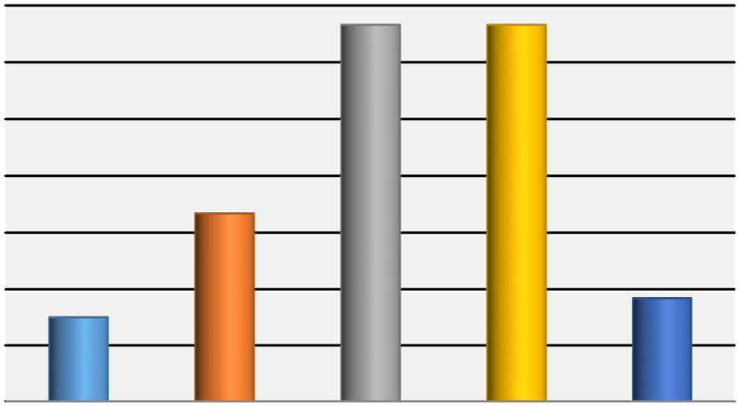

Totally

Lacking

Poor

Adequate

Good

Excellent

Series1

7.5

16.7

33.3

33.3

9.2

Series1, Totally

Lacking, 7.5

Series1, Poor,

16.7

Series1,

Adequate, 33.3

Series1, Good,

33.3

Series1,

Excellent, 9.2

Figure5. Percentages Selection of Content and Grading

# Language Component Presentation

As Table 11 shows, and although 21.7 percent of the responses evaluated the presentation of the language components in Prospect I as poor, about 62 percent believed that the concerned characteristic was well (28.3 %, Residual = 40) and adequately (33.5 %, Residual = 65) presented. About 17 percent selected the extreme options, i.e. 10.6 % excellent and 5.8 % totally lacking.

*Table 11*

*Frequencies and Percentages; Language Component Presentation*

Frequency Percent Residual

|  |  |  |  |
| --- | --- | --- | --- |
| Totally Lacking  Poor  Language  Adequate Component  Good  Presentation  Excellent | 28  104  161  136  51 | 5.8  21.7 33.5 28.3  10.6 | -68.0  8.0  65.0 40.0  -45.0 |
| Total | 480 | 100.0 |  |

The results of chi-square (χ2 (4) = 130.60, p < .05,) indicated that the differences observed in Table 11 were statistically significant. Thus it can be concluded that the Iranian EFL teachers evaluated the presentation of language component for the Prospect I as good and adequate. Figure 6 also illustrate the teachers‟ evaluation in percent.

*Table 12*

*Chi-Square; Language Component Presentation*

|  |  |
| --- | --- |
|  | Choices |
| Chi-Square | 130.604d |
| Df | 4 |
| Asymp. Sig. | .000 |

a. 0 cells (0.0%) have expected frequencies less than 5. The minimum expected cell frequency is 60.0.

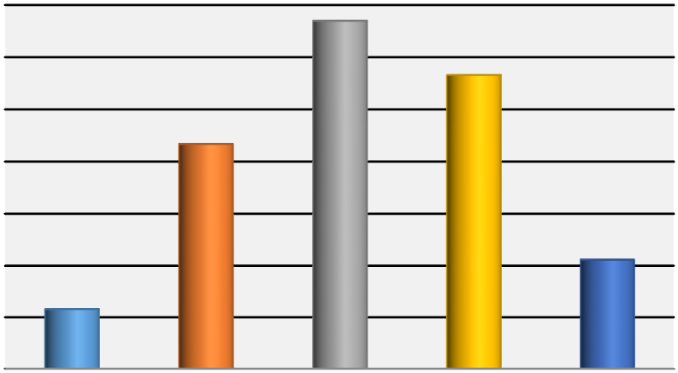

Totally

Lacking

Poor

Adequate

Good

Excellent

Series1

5.8

21.7

33.5

28.3

10.6

Series1, Totally

Lacking, 5.8

Series1, Poor,

21.7

Series1,

Adequate, 33.5

Series1, Good,

28.3

Series1,

Excellent, 10.6

*Figure 6. Percentages Language Component Presentation*

# Discourse and Style Appropriacy

As Table 13 shows, only two choices were selected more than expectation; adequate (26.3 %, Residual = 19) and good (34 %, Residual = 42). Thus, it can be claimed that majority of the respondents believed that Prospect I enjoyed an appropriate discourse and style. On the other hand, about 28 percent held the opposite view.

*Table 13*

*Frequencies and Percentages; Discourse and Style Appropriacy*

Frequency Percent Residual

|  |  |  |  |
| --- | --- | --- | --- |
| Totally Lacking  Poor  Discourse & Adequate  Style Appropriacy Good | 26  59  79  102 | 8.7  19.7 26.3  34.0 | -34.0  -1.0  19.0  42.0 |
| Excellent | 34 | 11.3 | -26.0 |
| Total | 300 | 100.0 |  |

The results of chi-square (χ2 (4) = 65.96, p < .05,) indicated that the differences observed in Table 13 were statistically significant. Thus, it can be concluded that the Iranian EFL teachers evaluated the appropriacy of discourse and style for the Prospect I as good and adequate. Figure 7 also illustrate the teachers‟ evaluation in percent.

*Table 14*

*Chi-Square; Discourse and Style Appropriacy*

|  |  |
| --- | --- |
|  | Choices |
| Chi-Square | 65.967e |
| Df | 4 |
| Asymp. Sig. | .000 |

a. 0 cells (0.0%) have expected frequencies less than 5. The minimum expected cell frequency is 60.0.

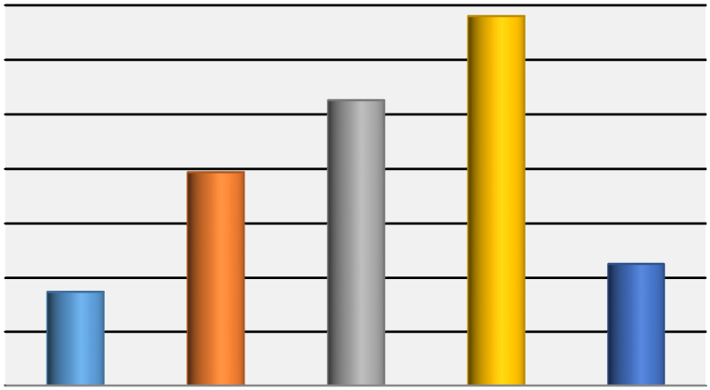

Totally

Lacking

Poor

Adequate

Good

Excellent

Series1

8.7

19.7

26.3

34

11.3

Series1, Totally

Lacking, 8.7

Series1, Poor,

19.7

Series1,

Adequate, 26.3

Series1, Good,

34

Series1,

Excellent, 11.3

*Figure 7. Percentages Discourse and Style Appropriacy*

# Language Development

As Table 15 shows, teacher held controversial attitude to the language development of Prospect I. Majority of the respondents (36.7 %, Residual = 20) believed that the presentation of language development was poor, while 30.8 percent evaluated it as adequate and another 25 percent believed it to be of good quality. A negligible percentage of 3.3 rated that is excellent, while 4.2 percent claimed that Prospect I totally lacked that quality.

*Table 15*

*Frequencies and Percentages; Language Development*

Frequency Percent Residual

|  |  |  |  |
| --- | --- | --- | --- |
| Totally Lacking  Poor  Language Adequate  Development Good | 5  44  37  30 | 4.2  36.7 30.8  25.0 | -19.0  20.0  13.0  6.0 |
| Excellent | 4 | 3.3 | -20.0 |
| Total | 120 | 100.0 |  |

The results of chi-square (χ2 (4) = 56.91, p < .05,) indicated that the differences observed in Table 4.35 were statistically significant. Thus, it can be concluded that the EFL teachers held opposite views on the quality of language development as appeared in Prospect I. Figure 8 also illustrate the teachers‟ evaluation in percent.

*Table 16*

*Chi-Square; Language development*

|  |  |
| --- | --- |
|  | Choices |
| Chi-Square | 56.917a |
| Df | 4 |
| Asymp. Sig. | .000 |

a. 0 cells (0.0%) have expected frequencies less than 5. The minimum expected cell frequency is 24.0.

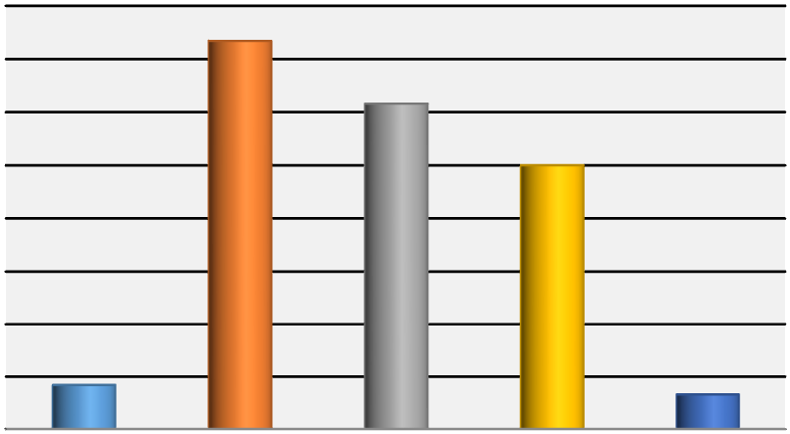

Totally

Lacking

Poor

Adequate

Good

Excellent

Series1

4.2

36.7

30.8

25

3.3

Series1, Totally

Lacking, 4.2

Series1, Poor,

36.7

Series1,

Adequate, 30.8

Series1, Good,

25

Series1,

Excellent, 3.3

*Figure 8. Percentages Language Development*

# Listening Skills Presentation

As Table 17 shows, although 22.7 percent of the responses evaluated the presentation of the listening skills in Prospect I as poor, about 52 percent believed that the concerned characteristic was well (24.7 %, Residual = 24) and adequately (27.3 %, Residual = 37) presented. About 27 percent selected the extreme options, i.e. 9.4 % excellent and 15.9 % totally lacking.

*Table 17*

*Frequencies and Percentages; Listening Skills Presentation*

Frequency Percent Residual

|  |  |  |  |
| --- | --- | --- | --- |
| Totally Lacking  Poor  Listening Skills Adequate  Presentation Good | 81  116  139  126 | 15.9 22.7 27.3  24.7 | -21.0  14.0 37.0  24.0 |
| Excellent | 48 | 9.4 | -54.0 |
| Total | 510 | 100.0 |  |

The results of chi-square (χ2 (4) = 53.90, p < .05,) indicated that the differences observed in Table 17 were statistically significant. Thus it can be concluded that the Iranian EFL teachers evaluated the presentation of listening skills for the Prospect I as good and adequate. Figure 9 also illustrate the teachers‟ evaluation in percent.

*Table 18*

*Chi-Square; Listening Skills Presentation*

|  |  |
| --- | --- |
|  | Choices |
| Chi-Square | 53.902f |
| Df | 4 |
| Asymp. Sig. | .000 |

a. 0 cells (0.0%) have expected frequencies less than 5. The minimum expected cell frequency is 102.0.

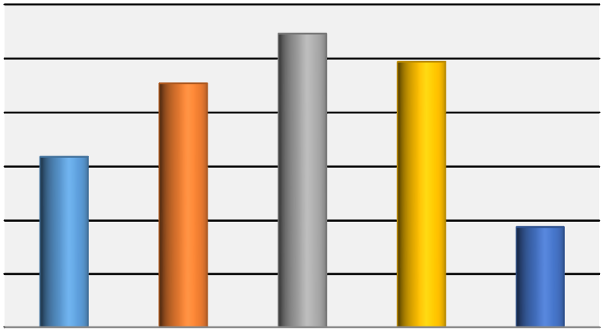

Totally

Lacking

Poor

Adequate

Good

Excellent

Series1

15.9

22.7

27.3

24.7

9.4

Series1, Totally

Lacking, 15.9

Series1, Poor,

22.7

Series1,

Adequate, 27.3

Series1, Good,

24.7

Series1,

Excellent, 9.4

Figure 9. Percentages Listening Skills Presentation

# Discussion

This research aims at investigating the value of the content materials and the factors involved in learning and teaching processes of the textbook in terms of teachability criteria. The results revealed thatIranian EFL teachers evaluated seven components including objectives, design and package, methodology, selection of content and grading, language component presentation, discourse and style appropriacy, and listening skills presentation as good and adequate. However, on the component of language development they held opposite views on the quality of language development as appeared in the book.

A comparison can be made between these findings and the findings of study conducted by Abbasian and Hassan-Oghli (2011) which proved that the main consumers are less satisfied with textbooks than their learners. This study is relatively aligned with that one concerning students‟ perspectives regarding their course book.

Another similar study conducted by Abbasian and Malmeer (2012) illustrated that teachers were more satisfied with some specific features than their students.However, it has been revealed by data analysis that there is a significant relationship between teachers and learners‟ perspectives towards the teachability and learnability of materials developed, the design of the book, language skills of the book, objectives of the book, and towards the content of the book for Iranian Junior Secondary Program. This study is the reflection of Iranian Junior Secondary Program English textbooks‟ strengths and weaknesses. Now, this is the responsibility of policy makers, curriculum planners and syllabus designers to amend or update the materials which have been newly developed and open new horizons for innovations which will consequently change Iranian Junior Secondary Program textbooks for betterment. In the same vein, another study conducted by Abbasian and Mahdavi (2012) revealed that teachers involved in ESP textbooks are more dissatisfied with them. Furthermore, Tok‟s (2010) study entitled “TEFL textbook evaluation: From teachers‟ perspectives” is relatively compatible with the present study in findings. His study “aims to examine the advantages and disadvantages of one type of TEFL materials, English language textbook „Spot On‟, used in state primary schools in Turkey.

One reason for such findings maybe is the shortcoming in syllabus design and material preparation of ESP textbooks in Iran. Rahimy (2008) discussed the compatibility of the content of the Medical ESP materials with the Iranian curriculum and believed there are many factors to be taken into account when writing ESP textbooks for speakers of other languages.

According to him “they could be genre analysis, contextualization, lexicon and grammar”.

Ajabshir (2011) indicated the major deficiencies are related to the authors approach to language and methodology, lack of balance between language skills and insufficient inclusion of communication activities. Also Zangani (2009) confirmed these findings by criticizing Iranian ESP textbooks for being text based and structural. He said “the books hardly involve students in developing language skills and communication ideas”.

# Conclusions

The Prospect I was addressed from eight areas in terms of the teachability characteristics as evaluated by those teachers having some practical the experiences of practicing the content. These eight categories include objectives, design and package, methodology, selection of content and grading, language component presentation, discourse and style appropriacy, language development, listening skills presentation. In general, the teachers evaluated the textbook in terms of the target characteristics as good and adequate. Concerning the objectives, statistically significant differences were observed indicating that the teachers evaluated the objectives of the Prospect I as good and adequate. The same holds true with respect to the Design and Package. The methodological orientation followed in the text book was also evaluated positively. As an another dimension; Selection of Content and Grading, was similarly evaluated positively, though the percentage of the options revealed a different picture. Language Component Presentation, Discourse and Style Appropriacy, Language Development, and finally Listening Skills Presentation were the remaining four other areas which were evaluated as good and adequate.

So, the textbook, is concluded, enjoying a relative degree of integrated, synchronized, well-balanced, and neatly interwoven subsection, though the psychometrics of analysis of each dimension varied from each other. Overall, the teachers assume that the textbook relatively enjoy teachability features as all of the aspects were commonly enjoyed higher frequency of being Good and Adequate. Still there are controversies among the teachers on the higher adequacy of the textbook, which implies necessity of considering revisions so that optimum level of integration and synchronization can be ensured.

# References

Abbasian, G., & Hassanoghli, E. (2011). Evaluation of Iranian EFL Textbooks: (A study of learner- teacher‟s criteria compatibility). *The Iranian EFL Journal, 7*(4), 176 – 202.

Abbasian, G., & Mahdavi, A. (2012). *ESP Textbook Evaluation: Teacherlearner' Maxims.* Lambert Academic Publishing.

Abbasian, G., & Malmeer, B. (2012). Consumers‟ Evaluation of the Content Parameters. *EFL Journal, 8*(5), 224-245.

Ajabshir, Z. (2011). Evaluation of "English for the students of Management . *The Iranian EFL Journal, 7*(4), 72-91. Retrieved August 10, 2011, from www.iranian-efl-journal.com

Allwright, R. (1981). What Do We Want Teaching Materials for? *ELT Journal, 1*(36), 170-192.

Ansari, H., & Babaie, E. (2002). A Bell-jar Consensus-reached Set of Universal Characteristics of ELT. In J. Mukundan, *Readings on ELT Materials* (pp. 69-83). Serdang: Universitiy Purta Malaysia.

Brown, J. (1995). *The Elements of Language Curriculum: A Systematic Approach to Program Development.* Boston: Heinele and Heinele Publisher.

Brown, J. (2001). *Using Surveys in Language Programs.* Cambridge: Cambridge University Press.

Clarke, D. F. (1989). Communicative Theory and Its Influence on Materials Production. Language Teaching, 22, 73-86.

Cunningsworth, A. (1984). *Evaluating and selecting EFL teaching materials*.London: Heinemann Educational Books.

Cunningsworth, A. (1995). *Choosing Your Course Book.* Oxford: Heinemen.

Ebel, E. (1980). The Empirical Evaluation of Language Teaching Materials. *ELT Journal, 51*(1), 554.

Garinger, D. (2001). Textbook Evaluation. TEFL Web Journal. Retrieved July 31, 2010, from www.teflweb-j.org / garinger.html

Hutchinson, T., & Torres, E. (1994). The Textbook as Agent of Change. *ELT Journal, 4*(48), 315-328.

Hutchinson, T., & Waters, A. (1987). *ESP : A Learning-centered Approach.* Cambridge: Cambridge University Press.

Krashen, S. (1985). *The Input Hypothesis.* Harlow: Longman.

Lightbown, P. (2000). Classroom SLA Research and Second Language Teaching. *Applied Linguistics, 21*, 431-462.

Lightbown, P. (2000). The importance of timing in focus on form. In C. Doughty, & J. Williams, *Focus on Form in Classroom Second language Acquisition.* Cambridge: Cambridge University Press.

Mashuara, H. (2008). Adult EFL Course. *ELT Journal, 62*(3).

Pienemann, M. (1985). Is Language Teachable? Psycholinguistic Experiments and Hypotheses. *Applied Linguistics, 10 (1)*, 52–79.

Rahimy, R. (2008). An Evaluation of Available Textbooks: Medical Terminology. Tonekabon, Iran. Retrieved August 22, 2011, from www.esp-world.info/Articles_17/PDF/Ramin_Rahimy.pdf

Richards, J. C. (2003). *Curriculum Development in Language Education.* Cambridge: Cambridge University Press.

Richards, J. C., & Renandya, W. A. (2002). *Methodology in Language Teaching: An Anthology of Current Practice.* Cambridge: Cambridge University Press.

Sheldon, L. (1988). Evaluating ELT Textbooks and Materials. *ELT Journal, 24*(4), 237-246.

Skierso, A. (2001). Textbook Selection and Evaluation. In M. Celce-Murcia, *Teaching English as a Second or Foreign Language* (pp. 432-453).

Boston: Heinle and Heinle Publishers.

Tok, H. (2010). TEFL Textbook Evaluation: From Teachers‟ Perspectives. *Educational Research and Review, 5*(2), 508-517.

Tomlinson, B. (2003). *Developing Materials for Language Teaching.* London: Cromwell Press.

Tomlinson, B. (2011). *Materials Development in Language Teaching.* Cambridge: Cambridge University Press.

Williams, D. (1983). Developing Criteria for Textbooks Evaluation. *ELT Journal, 37*(3), 251-255.

Zangani, E. (2009). Evaluation of ESP Textbooks in Humanities in the Undergraduate Program of Iranian Universities. *5 (2)*, 93-106.

1. *Imam Ali &IA universities (South Tehran Branch)-gabbasian@yahoo.com* 
2. *IAU (South Tehran Branch)*